Motion Analysis of a Four-Bar Linkage
By – Mehak Verma
Objective
To study the motion and dynamic behaviour of a four-bar linkage using Altair Inspire Motion Analysis.
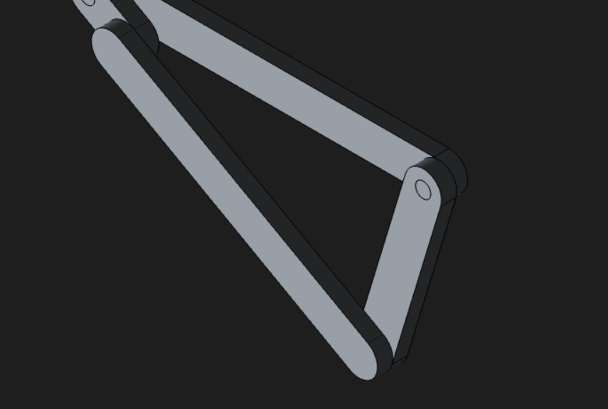
Setup
- The bottom link was grounded to provide a fixed reference.
- Four Hinge (Revolute) joints were created at the four connecting points.
- The motor was applied at the crank-ground joint to rotate the crank.
- A spring and gravity were added to study their effects on the mechanism.
- Proximity conditions were defined between the coupler–rocker and coupler–ground.
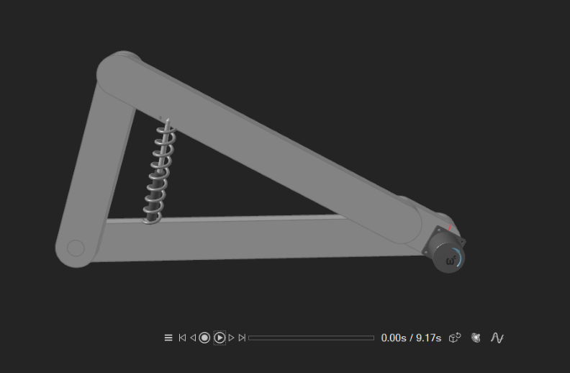
Working
- The motor rotates the crank about its fixed ground pivot. This motion is transferred to the coupler, which causes the rocker to oscillate about its ground pivot. Thus, continuous rotary motion from the motor is converted into oscillatory motion of the rocker.
- Gravity acts on the moving links, while the spring provides an additional restoring force, affecting the overall dynamic response.

Interpretation of Simulation Results
- The motion simulation demonstrated the expected operation of the four-bar linkage.

10.1 Crank motion
- The crank acted as the input member and rotated about the fixed crank-ground joint due to the motor input.
- The grounding of the bottom link ensured that the crank's pivot remained stationary while allowing the crank itself to rotate.
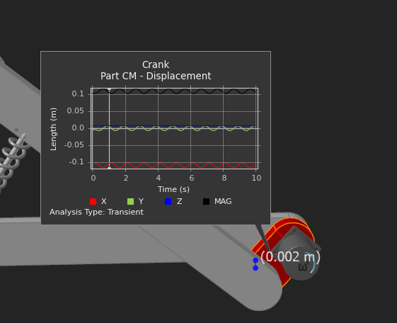

10.2 Coupler motion
- The coupler experienced a combination of translational and rotational movement. Its motion was governed by the movement of the crank and the constraint imposed by the rocker.
- This demonstrates the characteristic complex motion of a coupler link in a four-bar mechanism.
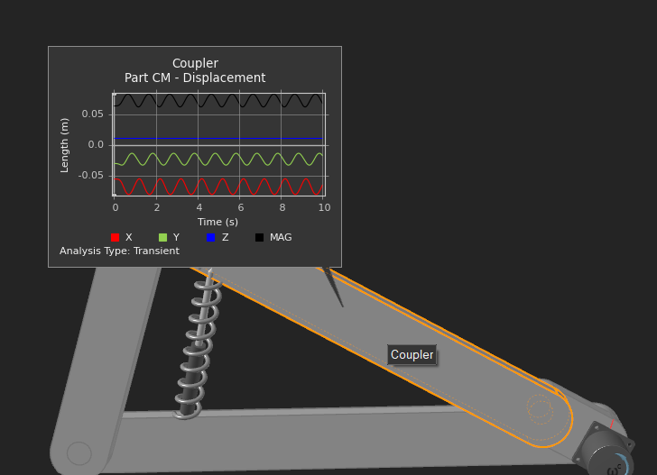

10.3 Rocker motion
- The rocker converted the coupler movement into angular oscillation about its fixed ground pivot.
- Therefore, although the motor supplied continuous rotary motion to the crank, the rocker exhibited a reciprocating/oscillatory motion.
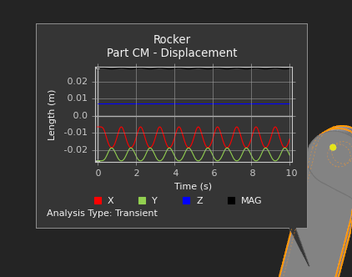

10.4 Effect of gravity
- Gravity acted continuously on the moving links and contributed to the dynamic forces within the mechanism. Depending on the instantaneous position of the linkage, gravity either assisted or opposed the motion of individual links.

10.5 Effect of spring
- The spring introduced an additional restoring force into the system. Its force varied with its deformation and consequently affected the motion of the connected mechanism.
- The combination of motor input, gravity and spring force therefore produced the final dynamic response observed during the simulation.
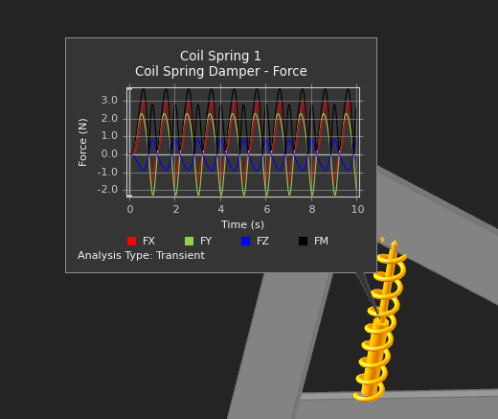
Proximity Results
- Case 1 – Coupler and Rocker:
The proximity distance remained 0 m throughout the simulation. This is because the coupler and rocker are connected through a hinge joint, so the selected surfaces remain coincident at the connection.
- Case 2 – Coupler and Ground:
The proximity distance was not constant. It varied continuously with time as the coupler moved relative to the ground. The graph shows the clearance changing during the simulation .
